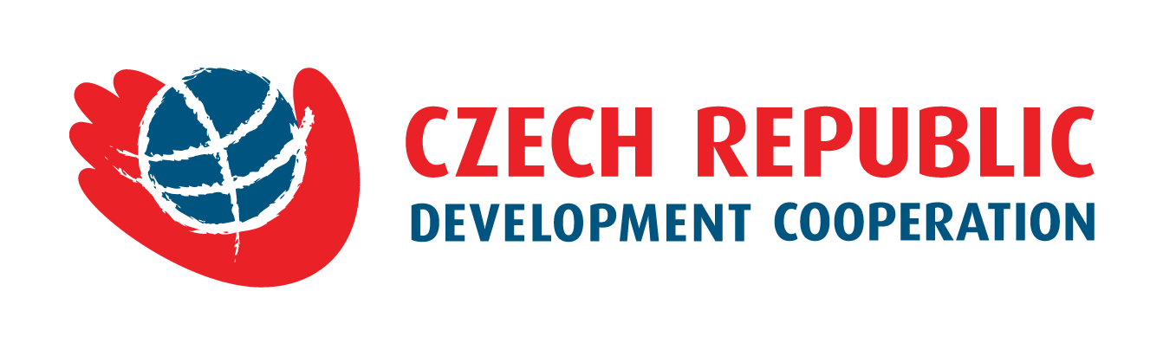

Announcement of a public contract “Digitalization of utility networks by using open source GIS software in Soroca, Edinet, Ungheni, Orhei, Cahul and Comrat municipalities” financed from the state budget of the Czech Republic.

The company GEOtest a.s., through the Ministry of Agriculture, Regional Development and Environment (MARDM) announces a procurement procedure „Digitalization of utility networks by using open source GIS software in Soroca, Edinet, Ungheni, Orhei, Cahul and Comrat municipalities.”
The Subject of the contract is to digitize and to transfer the information pertaining to the position and other relevant information of the utility networks within a given cadaster. The processed data will be stored in a GIS database by using open-source GIS tools.
The maximum permissible offer price of the supplier is determined by the Contracting authority in the amount of 1.100.000, - MDL.
This contract is financed from the state budget of the Czech Republic within Development cooperation of the Czech Republic and Moldova. Funding will be allocated directly through the project implementer: "Support for the implementation of the regional strategy using GIS data", by company GEOtest, a. s.
The offer must be physically delivered in sealed and properly marked envelopes to the Ministry MADRM, Constantin Tănase 9, MD-2005, Chişinău, Republic of Moldova by 9th March 2021, 10:00.
More information, including tender documents, can be found in the appendices.

